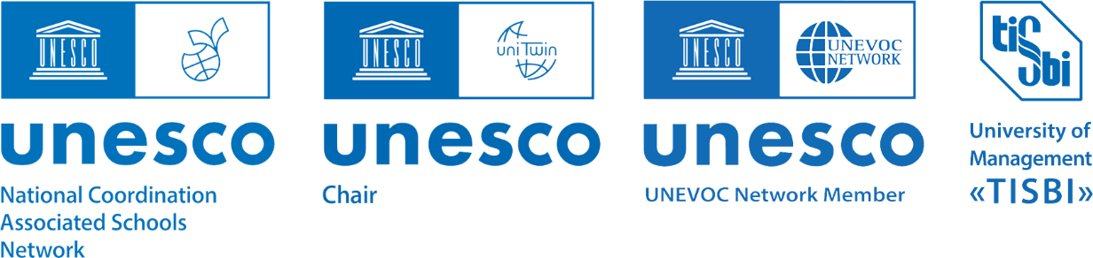

**International scientific and practical conference:**

**‘Development of Education through Artificial Intelligence’**

**(online)**

*September 20, 2024, Kazan*

University of Management "TISBI"

**PROGRAM PROPOSAL**

|  |  |  |  |
| --- | --- | --- | --- |
| ***Time*** | ***Activity*** | ***Conference venue*** | ***Link*** |
| ***9.30 – 10.00*** | Registration of Conference participants (online) | University of Management "TISBI" | -- |
| ***10.00-11.30*** | Official opening ceremony of the Conference. **Plenary session** | University of Management "TISBI" | <https://us06web.zoom.us/j/82811637738?pwd=yoKIe7lr1gDhXNtOs39nXJwpftXWVR.1>  Conference ID: 828 1163 7738  Access code: 828 1163 7738 |
| ***12.00-13.00*** | **Lunchtime** |  |  |
| ***13.00-15.30*** | **Panel discussion**: ‘*The Place and Role of Artificial Intelligence in General Education’* | Municipal Educational Institution "Gymnasium 179 - Education Center" of the Novo-Savinovsky District, Kazan | <https://us06web.zoom.us/j/89671831343?pwd=4cq7QMwDqGuaIXJVJAGtWk0wBK84nW.1>  Conference ID: 896 7183 1343  Access code: 233611 |
| ***13.00-15.30*** | **Panel discussion**:‘*Experience of using Artificial Intelligence in Secondary Vocational Education’* | Faculty of Secondary Vocational Education, Saint Petersburg State University of Aerospace Instrumentation, Saint Petersburg | <https://guap.ktalk.ru/tp7c67ojikhl> |
| ***13.00-15.30*** | **Panel discussion**:*‘Use of AI Tools and Methods in Universities’* | University of Management "TISBI" | <https://us06web.zoom.us/j/83884158111?pwd=y9GHv5QlYN9DJFcUtaRJT296ukixyI.1>  Conference ID: 838 8415 8111  Access code: 281434 |
| ***15.30-16.00*** | **Summary of the Conference results. Approval of the resolution** | University of Management "TISBI" | <https://us06web.zoom.us/j/82922084825?pwd=CG35ETWRnJr6FWKlGuoY7j0SrDvoWn.1>  Conference ID: 829 2208 4825  Access code: 667132 |