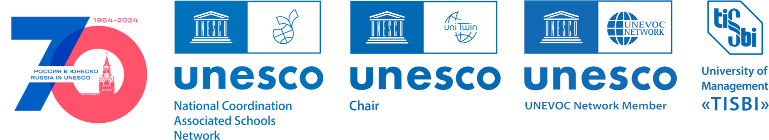

**Commission of the Russian Federation for UNESCO**

**Ministry of Education of the Republic of Tatarstan**

**UNESCO Institute for Information Technologies in Education**

**National Coordination Centre of the UNESCO Associated Schools Network (ASPnet)**

**UNESCO Chair of TISBI University**

**UNEVOC Center for Vocational Education and Training**

**TISBI College**

**SUAI UNESCO Chair**

**St. Petersburg State University of Aerospace Instrumentation**

**Russian Peoples’ Friendship University named after Patrice Lumumba**

**INFORMATION LETTER**

**International scientific and practical conference:**

**“Development of Education through Artificial Intelligence”**

**Dear Colleagues!**

We invite you to take part in the International Scientific and Practical Conference **“Development of Education through Artificial Intelligence”**. The conference will be held online.

**Conference Organiser:** the University of Management “TISBI”.

**Co-organisers:** Commission of the Russian Federation for UNESCO, Ministry of Education and Science of the Republic of Tatarstan, UNESCO Institute for Information Technologies in Education (IITE, Moscow), National Coordination Center of the UNESCO Associated Schools Network in Russian Federation, UNEVOC Centre of the University of Management “TISBI”, TISBI College, UNESCO Chair of the St. Petersburg State University of Aerospace Instrumentation (St. Petersburg), Russian Peoples’ Friendship University named after Patrice Lumumba (Moscow), Ajeenkya D Y Patil University (India), Innopolis University (Innopolis), Gymnasium No. 179 - center of education of Novo-Savinovsky district of Kazan.

**The purpose of the Conference** is toexchange of experience in the field of improving the quality of education through the methods and tools of artificial intelligence.

**Objectives of the Conference:**

* to determine the place and role of artificial intelligence in education;
* to identify trends in the application of methods and tools of artificial intelligence in education;
* to generalize the experience of application of artificial intelligence in education.

The work of the Conference is planned in the following directions:

* natural language processing;
* recommendation systems;
* topic modeling;
* ontologies and knowledge graphs;
* computer vision;
* speech processing and recognition;
* clustering and segmentation.

**Conference sections:**

**Section 1**. The place and role of AI in general education.

**Section 2.** Experience in the application of AI in secondary vocational education.

**Section 3.** Application of AI methods and tools in higher-educational institutions.

**The following professionals are invited to participate in the Conference:** leading foreign and Russian scientists - specialists in the field of higher professional education, basic general education, secondary vocational education; developers of digital educational products and tools; also UNESCO Chairs, UNEVOC Centers for Vocational Education and Training, UNESCO Associated Schools, educational organizations of general and secondary education, teachers, methodologists.

**We plan to publish a Collection of scientific articles based on the results of the Conference**. The collection of Conference materials will be assigned an International Standard Book Number (ISBN), Universal Decimal Classification (UDC), Library, and Bibliographic Classification (LBC) codes. The collection of Conference materials will be posted in the RSCI (agreement No. 18109 dated January 29, 2019).

ELECTRONIC COLLECTION OF CONFERENCE MATERIALS AND CONFERENCE PARTICIPANT CERTIFICATE ARE PROVIDED FREE OF CHARGE!

**Conference Venues:**

University of Management “TISBI” (online).

Gymnasium No. 179 - center of education (online).

St. Petersburg State University of Aerospace Instrumentation (online).

**Date:** September 20, 2024.

**Conference language:** Russian, English.

**Conference format:** online.

**Form of participation in the Conference:** giving a speech and a presentation remotely, participating in online discussions;publishing scientific papers.

**Registration of participants:** registration of participants via the link: <https://forms.gle/AF1AdFJoqMvsvRfb7>.

There is **no registration fee** for participants from other countries.

**Contact Details:**

### Anastasia Katekina, Vice-Rector for International Relations, Ph.D., Associate Professor, University of Management “TISBI”, [akatekina@gmail.com](mailto:akatekina@gmail.com).

**Guidelines for submitting articles**

The author’s original is prepared in electronic format using the MICROSOFT WORD editor. Sheet size – A4 portrait mode. Text length – from 3 to 15 pages; character size -14 points, spacing 1.5; Times New Roman font; paragraph 1.25; margins: 20 mm – top, bottom; 30 mm – left; 10 mm – right; footnotes in square brackets within the text, bibliography at the end of the text. Materials should not contain highlights or subscripts.

Further, in the center, the title of the article is printed in capital letters, the font is bold. Below, in one-and-a-half intervals in lowercase letters, are the initials and surname of the author(s), academic degree and full name of the organization. After a one-space indentation, the abstract and keywords come with a two-space indentation followed by the main text. The list of references is also separated by one indent and contains no more than three sources. Abstracts and articles containing plagiarism and incorrect borrowings, as well as articles with text originality of less than 60% cannot be accepted for publication. The scientific supervisor acts as a guarantor of the quality of the materials provide

**Up to August 10, 2024,** a publishing paper should be sent to the following e-mail: [konftisbi22@gmail.com](mailto:konftisbi22@gmail.com).

Article writing format (sample)

**ANALYSIS OF THE BANK GUARANTEE**

**Petrov V.E.,** Ph.D. in Technical Sciences

Kuzbass State Technical University, Kemerovo

**Abstract.** The article studies the advantages and disadvantages, considers the classification and mechanism of action of the bank guarantee.

**Key words**: bank guarantee, insurance, loan security.

Text of the article……………

**Literature:**

1. …